ASSIGNMENT NO.9: Data Retrieval, Functions, and Joins in MySQL

Student Name | Amit Shivaji Panorekar | Roll Number | 20968
Batch | SY. BSc Data Science | Topic | WB(Assignment-9)

Questions:
Q1) Create a MySQL database named CollegeDB and create two tables: OnlineEnrollment and OfflineEnrollment.

OnlineEnrollment Table
Column Name | Data Type | Constraint
StudentID | INT | PRIMARY KEY
StudentName | VARCHAR(50) | NOT NULL
CourseID | VARCHAR(30)
City | VARCHAR(30)
Marks | INT

OfflineEnrollment Table
Column Name | Data Type | Constraint
StudentID | INT | PRIMARY KEY
StudentName | VARCHAR(50) | NOT NULL
CourseID | VARCHAR(30)
City | VARCHAR(30)
Marks | INT

Insert at least 6 records into each table. Some records should be common in both tables.
Query-
CREATE DATABASE CollegeDB;

USE CollegeDB;

CREATE TABLE Course (
CourseID INT PRIMARY KEY,
CourseName VARCHAR(50) NOT NULL, Fees DECIMAL(10,2) NOT NULL
);

CREATE TABLE Student (

StudentID INT PRIMARY KEY,
StudentName VARCHAR(50) NOT NULL, CourseID INT,
City VARCHAR(30),
Marks INT,
Email VARCHAR(60),
FOREIGN KEY (CourseID) REFERENCES Course(CourseID)
);

INSERT INTO Course
(CourseID, CourseName, Fees) VALUES
(101, 'BSc IT', 45000.00),
(102, 'BCA', 40000.00),
(103, 'BSc CS', 42000.00),
(104, 'Data Science', 55000.00);

INSERT INTO Student
(StudentID, StudentName, CourseID, City, Marks, Email) VALUES
(1, 'Rahul Sharma', 101, 'Mumbai', 78, 'rahul@gmail.com'),
(2, 'Priya Patil', 102, 'Pune', 85, 'priya@gmail.com'),
(3, 'Aman Verma', 103, 'Nashik', 67, 'aman@gmail.com'),
(4, 'Sneha Joshi', 101, 'Mumbai', 91, 'sneha@gmail.com'),
(5, 'Karan Mehta', 102, 'Thane', 74, 'karan@gmail.com'),
(6, 'Neha Shah', 101, 'Pune', 88, 'neha@gmail.com'),
(7, 'Rohan Desai', 103, 'Mumbai', 69, 'rohan@gmail.com'),
(8, 'Meera Kulkarni', 102, 'Nashik', 82, 'meera@gmail.com'),

(9, 'Arjun Nair', 101, 'Thane', 59, 'arjun@gmail.com'),
(10, 'Divya More', 102, 'Mumbai', 93, 'divya@gmail.com');

2) Write a MySQL query using UNION to display all unique students from both OnlineEnrollment and OfflineEnrollment.
The output should contain:
Column
StudentID
StudentName
Course
City
Marks

Query-
SELECT StudentID, StudentName, Course, City, Marks FROM OnlineEnrollment

UNION

SELECT StudentID, StudentName, Course, City, Marks FROM OfflineEnrollment;
Output-
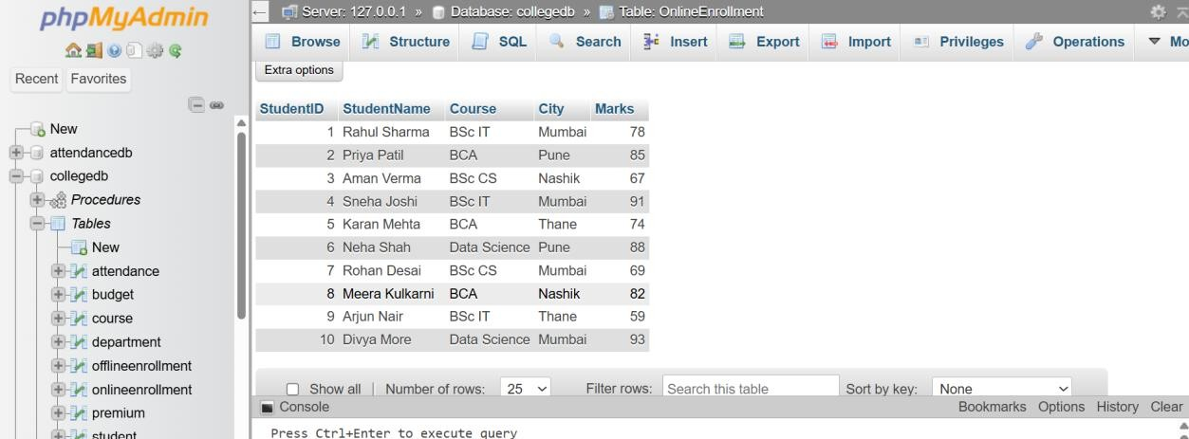

Q3) Write a MySQL query using UNION ALL to combine records from both tables while

keeping duplicate records.
Also write one line explaining the difference between UNION and UNION ALL.

Query-
SELECT StudentID, StudentName, Course, City, Marks FROM OnlineEnrollment

UNION ALL

SELECT StudentID, StudentName, Course, City, Marks FROM OfflineEnrollment;
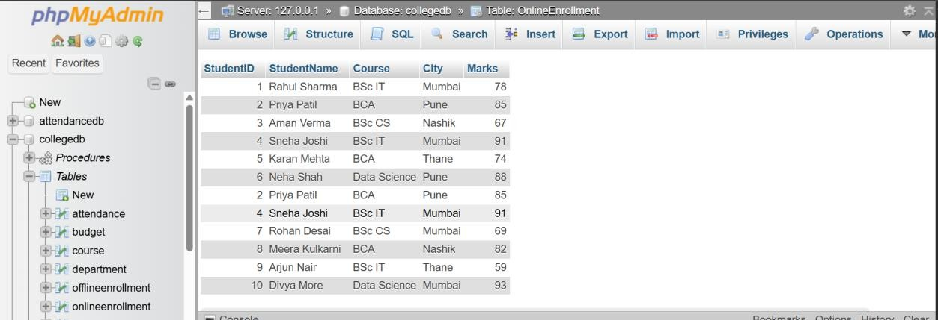

Q4) Write a MySQL query using INTERSECT to display students who are present in both online and offline enrollment tables.
The output should contain:
Column
StudentID
StudentName
Course
City
Marks

Query-
SELECT StudentID, StudentName, Course, City, Marks FROM OnlineEnrollment

INTERSECT

SELECT StudentID, StudentName, Course, City, Marks FROM OfflineEnrollment;
Output-
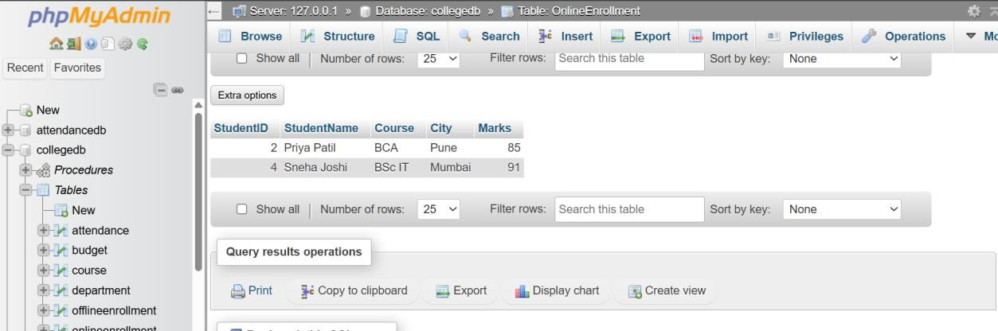

Q5) Write a MySQL query using EXCEPT to display students who are present only in the online enrollment table.
The output should contain:
Column
StudentID
StudentName
Course
City
Marks

Query-
SELECT StudentID, StudentName, Course, City, Marks FROM OnlineEnrollment
EXCEPT
SELECT StudentID, StudentName, Course, City, Marks FROM OfflineEnrollment;
Output-

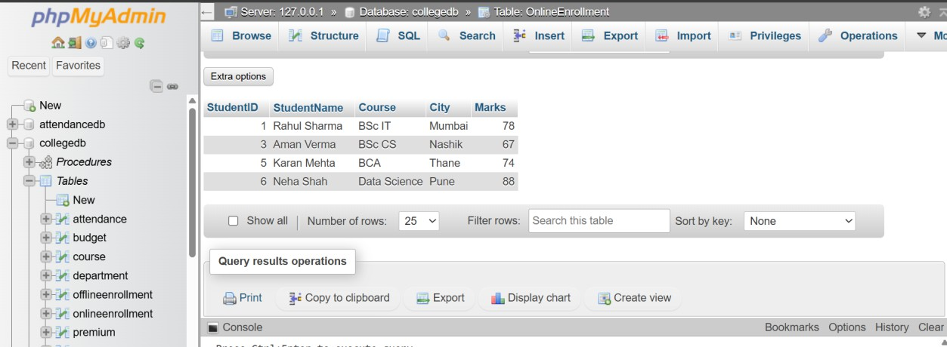

Q6) Write a MySQL query to display high-scoring students from both tables. The query should:
Requirement
Select students with marks greater than or equal to 85
Use UNION to combine both tables
Display StudentID, StudentName, Course, and Marks
Sort the final output by Marks in descending order

Query-
SELECT StudentID, StudentName, Course, Marks FROM OnlineEnrollment
WHERE Marks >= 85 UNION
SELECT StudentID, StudentName, Course, Marks FROM OfflineEnrollment
WHERE Marks >= 85 ORDER BY Marks DESC;

Output-

